Annex 4: Standard Text for Description of WHO Guidance to Include in Section II of the WQAP.
WHO Guidance: The World Health Organization (WHO) provides additional guidance and recommendations on the monitoring and management of critical water quality parameters, which should be incorporated into the WQAP. Specific guideline values and standards can differ between US EPA, WHO and host country regulations; therefore, the IP should evaluate each standard to determine the most appropriate guideline values for the project.

The primary WHO reference on drinking water is the Guidelines for Drinking Water Quality, Fourth Edition (WHO, 2017). According to the WHO, these guidelines… “support the development and implementation of risk management strategies that will ensure the safety of drinking-water supplies through the control of hazardous constituents of water.” WHO has established guideline values for over 90 drinking water quality parameters, including microbial, chemical, and radiological parameters. Of these 90 parameters, tables of selected parameters to address microbial and chemical contamination are noted below. The WHO suggests the use of Escherichia coli (E.coli), or alternatively thermotolerant coliforms, as a fecal indicator organisms, the absence of which provides a high degree of assurance that fecal contamination is not present. Strictly speaking the absence of E. coli or thermotolerant coliforms does not guarantee the absence of other forms of fecal contamination as some microbial fecal contaminants, including Enteric viruses and protozoa, are more resistant to disinfection. Therefore, inadequate disinfection may eliminate some microbial populations but not eliminate the all disease pathogens. However, generally speaking, for the purposes of monitoring water quality E. coli or termotolerant coliform tests can be performed to determine if fecal contamination has occurred.

Microbial Quality: The WHO guidelines for microbial contamination summarized in Table 1 recommend a value for Escherichia coli, (or E. coli.) or thermotolerant coliforms (TtC) bacteria. <Detailed processes for the assessment and treatment of bacteriological contamination are included in the WHO guidelines, and should be consulted for specific concerns (e.g. disinfection treatment technologies).>
Table 1: WHO Guideline Values for Microbial Quality
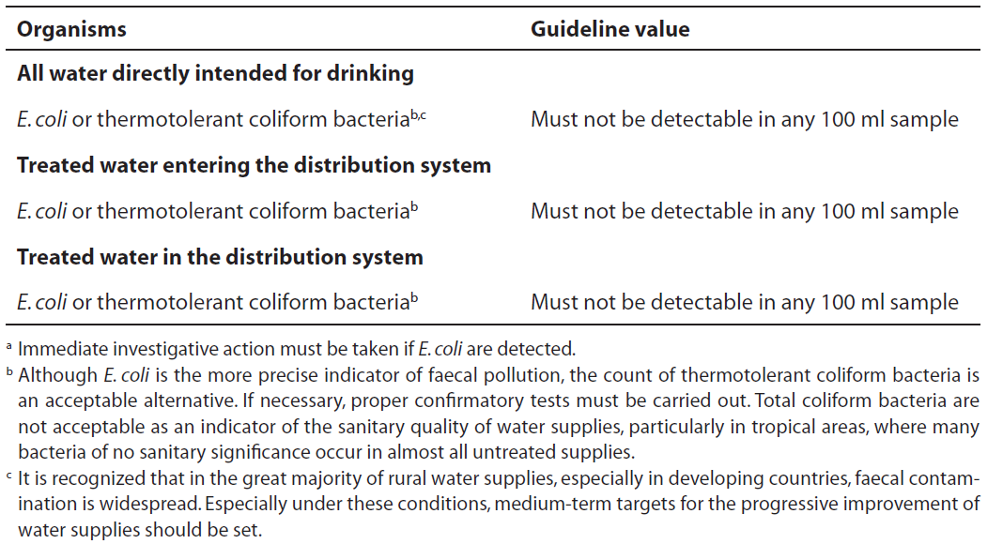
Chemical Quality: The WHO guidelines include values for chemicals which are naturally occurring as well as chemicals used in household, industrial and agricultural settings. <The WHO guideline values for chemicals from household and industrial activities, which may be present in drinking water and pose a public health concern, are not presented here but should be reviewed if site specific concerns for these chemicals are suspected or noted during the initial review of country regulations, the investigation of nearby water quality findings, or the site survey>.
As shown in Table 2, the naturally occurring chemicals for which there are WHO guideline values are inorganic, except for the organic chemical Microcystin-LR, which is a product of blue green algal blooms in surface waters. Because the occurrence of these naturally occurring chemicals depends on site-specific hydrological and geologic conditions, monitoring of these parameters is not necessary for all programs.
Table 2: WHO Guideline Values for Naturally Occurring Chemicals
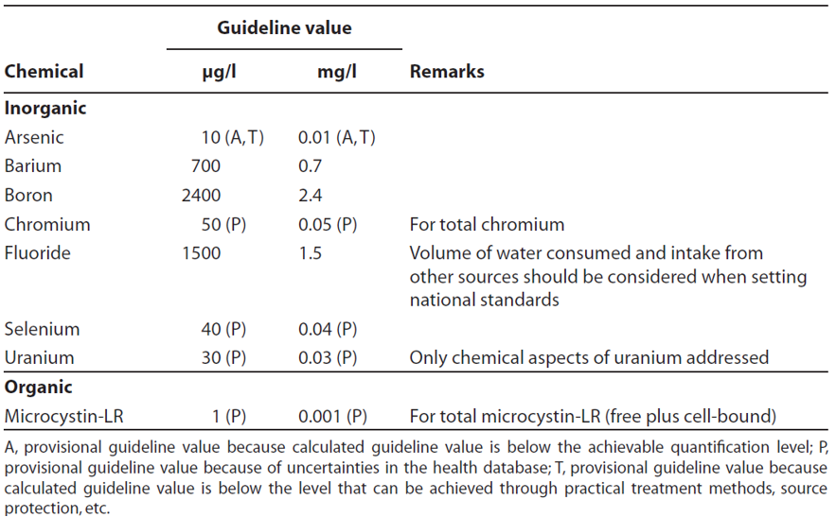
As noted in Table 3, WHO guideline values for nitrates and nitrites result from the use of nitrogen-based fertilizers in agricultural activities. <The WHO guidance also includes values for agricultural pesticides, which should be consulted at locations where such pesticides are stored or used.>
Table 3: WHO Guideline Values for Non-Pesticide Agricultural Chemicals
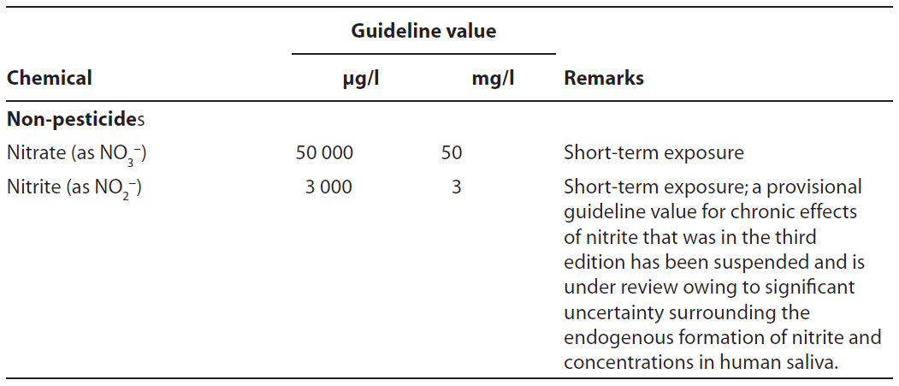
Nitrate: The parameter nitrate is of concern in drinking water from non-agricultural areas as well. Nitrate can be an indicator of contamination from untreated human waste, often from inadequately maintained sanitation facilities such as latrines, cesspools or septic tank systems. To protect bottle-fed infants from methaemoglobinaemia (i.e. blue-baby syndrome), the WHO has developed a guideline value of 50 mg/l for nitrate (as the nitrate ion) or 11 mg/l (as nitrate-nitrogen). WHO notes that, “Water should not be used for bottle-fed infants if the concentration of nitrate is above 100 mg/l but can be used if the concentration is between 50 and 100 mg/l if the water is microbiologically safe and there is increased vigilance by medical authorities” (WHO 2011).
Operational and Acceptability Monitoring: The WHO guidelines include values for certain parameters which may not pose a health hazard, but may pose operational or acceptability concerns. The acceptance or monitoring thresholds for selected parameters, including nitrate, TDS, pH, and turbidity are summarized below. <Selected parameters for operational and acceptability should be described as well.>
Total Dissolved Solids (TDS): Total dissolved solids, or TDS, is an important measure of dissolved salts, or conductivity, of the water. High values of TDS may result in taste concerns. According to the WHO, TDS levels below 600 mg/l are generally acceptable to most consumers, while levels above 1000 mg/l appear to result in water that is unpalatable. High levels of TDS may also result in excessive scaling in equipment.
Electrical conductivity (EC): Electrical conductivity (EC) in μS/cm, like TDS, is an indicator of conductivity. EC is relatively easy to measure in the field, and is used frequently as a surrogate for TDS. EC in μS/cm is usually 1 to 2 times the TDS in mg/l depending on the dissolved ion content of the water
Corrosion and pH: One of the most important operational parameters in water systems is pH. According to the WHO, the optimum range for pH for most water systems is 6.5 to 8. Control of pH within this range generally prevents corrosion and ensures proper operation and maintenance of the drinking water system.
Turbidity: Turbidity: Turbidity manifests itself as cloudiness in the water, resulting from suspended particles and colloidal material. It is a critical indicator of possible contamination of the water supply, notably in poorly or untreated surface waters, although turbidity itself is not necessarily a health concern. According to the WHO, for small water supplies with limited or no treatment, levels of turbiditly should remain below 5 NTU, and, if possible, below 1 NTU.
Additional WHO guidance documents on drinking water quality are widely available and can be accessed at the WHO drinking water quality website at: http://www.who.int/water_sanitation_health/dwq/en/.

Excerpt from Table 7.10, “Guideline values for verification of microbial quality,” from WHO Guidelines for Drinking Water Quality (WHO, 2011)
Excerpt from Table 8.8, “Guideline values for naturally occurring chemicals that are of health significance in drinking water,” from WHO Guidelines for Drinking Water Quality (WHO, 2011)
Excerpt from Table 8.13, “Guideline values for chemicals from agricultural activities that are of health significance in drinking water,” from WHO Guidelines for Drinking Water Quality (WHO, 2011)

